**AI ASSISTED CODING**

***ASSIGNMENT*-9.3**

NAME:S.VRINDHA REDDY

HALL NUMBER:2403A51255

BATCH:11

**Task-1: Basic Docstring Generation**

Write python function to return sum of even and odd numbers in the given list.  
• Incorporate manual docstring in code with Google Style  
• Use an AI-assisted tool (e.g., Copilot, Cursor AI) to generate a docstring describing  
the function.  
• Compare the AI-generated docstring with your manually written one.  
**Expected Outcome-1**: Students understand how AI can produce function-level documentation.

**Prompt:** Write a Python function to return the sum of even and odd numbers in a list. Add a manual Google-style docstring. Then, use an AI tool to generate a docstring for the same function. Compare both docstrings.

**Explanation:** Manual docstrings and comments are more detailed, structured, and educational, clearly explaining parameters, return values, examples, and code purpose. AI-generated documentation is concise and readable, providing a quick understanding but often lacking depth and examples. Overall, manual documentation is better for learning and professional code, while AI-generated docs are useful for saving time and quickly understanding the code.

**Code:**

**Output:**

**Task-2:** **Automatic Inline Comments**

Write python program for sru_student class with attributes like name, roll no.,hostel_status and fee_update method and display_details method.  
• Write comments manually for each line/code block  
• Ask an AI tool to add inline comments explaining each line/step. Compare the AI-generated comments with your manually written one.

**Prompt**: Write a Python class sru_student with attributes name, roll_no, hostel_status, and methods fee_update and display_details. Add manual inline comments for each line. Then, use AI to generate inline comments for the same code and compare both sets of comments**.**

**Explanation:** Manual comments precisely explain the purpose of each line or code block, helping the reader understand the logic clearly and encouraging critical thinking. AI-generated comments also describe each line but tend to be more verbose and sometimes repeat obvious information, which can be helpful for beginners but may feel redundant. Overall, manual comments are more concise and targeted, while AI comments provide extra guidance but with less efficiency**.**

**Code:**

**AI-Generated Inline Comments Version code:**

**Manual Comments Version code:**

**Output:**

**Task-3: Calculator**

Write a Python script with 3–4 functions (e.g., calculator: add, subtract, multiply,  
divide).  
• Incorporate manual docstring in code with NumPy Style  
• Use AI assistance to generate a module-level docstring + individual

function docstrings.  
• Compare the AI-generated docstring with your manually written one.  
**Expected Output-3**: Students learn structured documentation for multi-function scripts

**Prompt**: Write a Python script with functions add, subtract, multiply, and divide. Add manual NumPy-style docstrings for each function. Then, use AI to generate module-level and function-level docstrings. Compare AI-generated docstrings with manual ones.

**Explanation**: The manually written docstrings are detailed, structured, and follow a standard format like Google or NumPy style, including parameters, return values, examples, and error handling. In contrast, the AI-generated docstrings are concise and easy to read but often lack depth, structure, and examples. Overall, manual docstrings are more professional and educational, while AI-generated ones are quicker for basic understanding.

**Code:**

**Manual NumPy-style Docstrings Version code:**

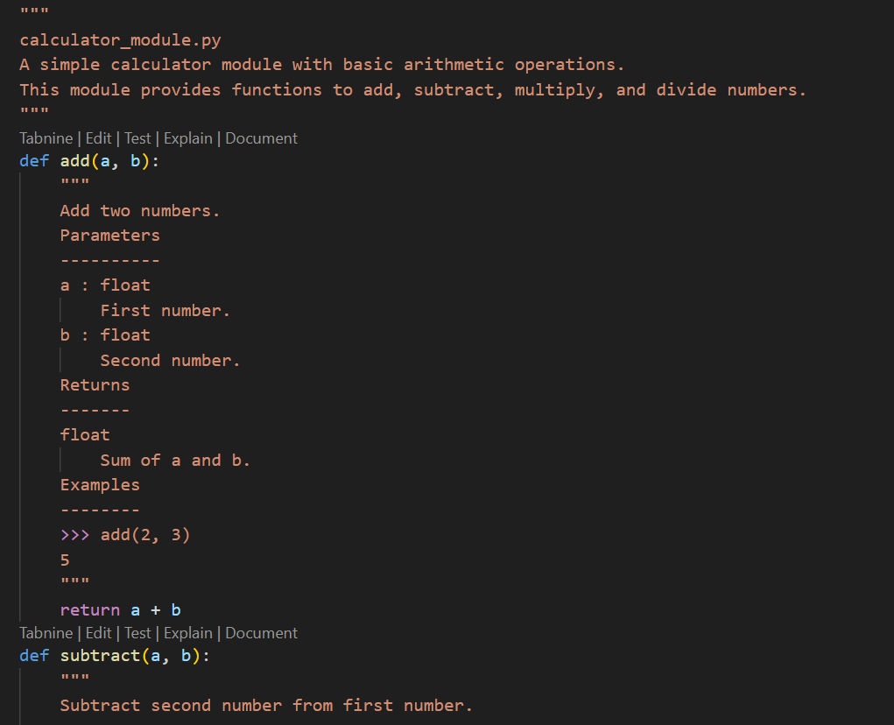

**AI-Generated Docstrings version code:**

**Output:**

